SIENA*college*

Damietta Cross-Cultural Center

**What are gender pronouns?**

Sometimes called preferred gender pronouns, these are words used to refer to a person that are chosen by the person to whom it refers. These can words like he, she, they, or ze.

**Why do pronouns matter?**

* You can’t ever tell someone’s gender just by looking at them.
* One of the most basic ways to show respect to another person is by asking for and correctly using someone’s pronouns.
* It is a privilege to not have to worry about what pronouns people assume for you. If you have this privilege and fail to respect someone else’s gender identity, it is not only disrespectful, but oppressive.

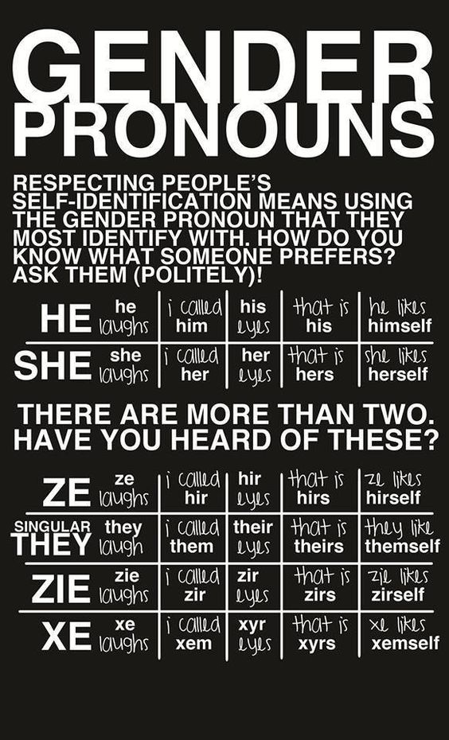

**How should I ask for someone’s gender pronoun?**

* “Hi, my name is ____ and my pronouns are ____. What is your name and pronouns?”
* “Do you know what pronouns ____ uses?”
* “What are your gender pronouns?”

**What if I make a mistake?**

This is totally fine. Mistakes can happen and they will happen, everyone slips up from time to time. The easiest way to correct yourself is to quickly say something such as, “I meant, she/he/they”, apologize, and move on with the conversation.

Making a big deal out of your mistake can be even more harmful than a small one, so recognize what happened and practice, practice, practice!

**In the classroom,** faculty have the opportunity to get to know everyone better and are able to respect people’s pronouns if asked on the first day of class. This can be done quickly, easily, and confidentially through a hand-out.

**In the office or around campus,** discussing and correctly using gender pronouns creates a level of respect and allyship that is a big part of Siena’s campus life.

**In electronic communication,** you can note your gender pronouns in your signature. Being mis-gendered in any situation can be hurtful.

*Adapted from material written by Mateo Medina for Hampshire College, modified for use at Siena College.*